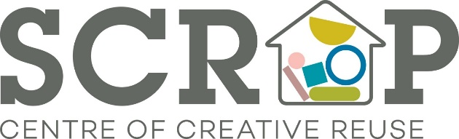
Scrap Creative Reuse Arts Project Ltd
First Floor, The Spinning Mill
Sunny Bank Mills
Farsley
Leeds LS28 5UJ
Tel: 0113 345 2627
Email: admin@scrapstuff.co.uk

June 2024

Dear Applicant
SCRAP Volunteer Support
Thank you for your interest in the above role.
Please note that the closing date for completed applications is 12 noon on Sunday 30th June 2024.
Applicants who have been shortlisted for interview will be notified by email during the week commencing 1st July 2024. Should you not hear anything by that date, unfortunately you have not been successful on this occasion, but I would like to wish you every success for the future and thank you for your interest in the role.
Interviews will take place the week commencing 9th July 2024.
Kind Regards

Louise Lucas
Director

