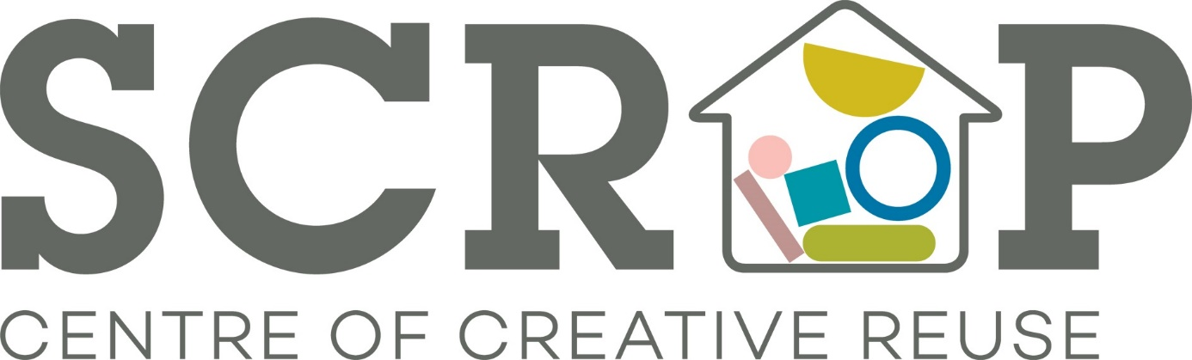

Thank you for your interest in volunteering with Scrap. Please read on for a breakdown of the role currently on offer.
If you are interested in pursuing this please complete and return the application form provided.
Please note this role of
SCRAP Volunteer Role: Scrap Shed Assistant and Warehouse Organiser
Potential time commitment: A minimum of one 6 hour day per week.
Available days/time: Mon – Fri 10am – 4pm
Location: Sunnybank Mills, The Spinning Mill, Farsley Leeds LS28 5UJ and Yorkshire wide for pick-up and delivery
Responsibilities/activity:
With the support of our Scrap Shed Co-ordinator
- Regularly drive to various locations across Leeds and Yorkshire to collect scrap materials donated by a range of businesses and organisations
- Travel across Leeds and Yorkshire to schools helping fill and replenish Scrap Sheds
- Keep the Scrap Store well stocked with a variety of materials, including transferring stock between two sites, which can involve heavy lifting
- Load and unload the Scrap van involving heavy lifting, observing good practice of health and safety regulations
- Work with the staff team and volunteers to keep the Scrap Store well stocked with a variety of materials, including transferring stock between sites
- Manage time and collection schedule with relevant Scrap staff and volunteers
- Load and unload the van observing good practice in Health and Safety regulations
- Oversee van maintenance
- Help keep our warehouse and stock room tidy and well organised
- Restock, label boxes and track rotation of stock to prevent spoilage
Requirements:
- Full, clean UK drivers’ licence, experience of driving vans and safe and responsible driving
- Excellent interpersonal skills including a polite, friendly, and approachable manner with colleagues, customers and supliers
- Ability to work well with other volunteers as part of a team
- Interest in and awareness of environmental issues/recycling
- Good practice of Health & Safety regulations with regards to manual work

Training and support:
Full training on all relevant responsibilities will be provided, including a general Health and Safety induction. SCRAP will aim to provide opportunities for personal development within your role.
What you will get from this role:
- Develop your skills and experience and confidence
- Join a motivated, fun, and creative team of volunteers
- Take pride in the knowledge that you are helping a valuable local social enterprise that benefits your community
- Gain experience that will enhance your CV
- Reasonable expenses covered (bus fares and lunch money)
Health and safety responsibilities:
To be responsible for your own health and safety and that of others with whom you volunteer by reporting all potential and actual health and safety matters including accidents using the correct procedures.

(end)

