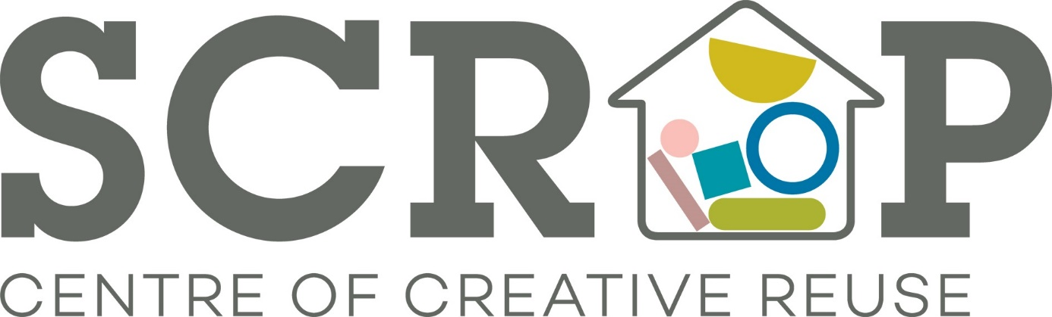

Thank you for your interest in volunteering with Scrap. Please read on for a breakdown of the role currently on offer.
If you are interested in pursuing this please let us know and we will invite you in for a chat with our Volunteer Co-ordinator, Mari, on a Weds, Thurs or Fri between 10am – 4pm. Email us on hello@scrapstuff.co.uk with a little bit about yourself including your availability.
SCRAP Volunteer Role: Van Driver & Warehouse Organiser
Potential time commitment: Flexible (minimum 4 hour shift)
Available days/time: Weds – Fri 10am – 4pm
Location: Sunnybank Mills, The Spinning Mill, Farsley Leeds LS28 5UJ and Yorkshire wide for pick-up and delivery
Responsibilities/activity (to include all or some of the following):
- Regularly drive to various locations across Leeds and Yorkshire to collect scrap materials donated by a range of businesses and organisation
- Make deliveries within a certain radius of the Scrapstore when the Scrap online store is up and running
- Work with the staff team and volunteers to keep the Scrapstore well stocked with a variety of materials, including transferring stock between sites
- Manage time and collection schedule with relevant Scrap staff and volunteers
- Load and unload the van observing good practice in Health and Safety regulations
- Swap materials with other Scrapstores (one-to-one basis and at multiple Scrapstore ‘big swaps’)
- Oversee van maintenance
- Contribute to keeping our warehouse and stock room tidy and well organised
- Restock, label boxes, track and supervise rotation of stock to prevent spoilage
Requirements:
- Excellent interpersonal skills including a polite, friendly, and approachable manner
- Ability to work well with other volunteers as part of a team
- Interest in creative skills and environmental issues (recycling)
- Good practice of Health and Safety regulations with regards to manual work
- Hold a full driving licence and drive in a safe, responsible manner and always obey the law

Training and support:
Full training on all relevant responsibilities will be provided, including a general Health and Safety induction. SCRAP will aim to provide opportunities for personal development within your role.
What you will get from this role:
- Develop your skills and experience
- Join a motivated, fun, and creative team of volunteers
- Take pride in the knowledge that you are helping a valuable local social enterprise that benefits your community
- Gain experience that will enhance your CV
- Meet new people
- Reasonable expenses covered (bus fares and lunch money to the value of £5.00 per day)
Health and safety responsibilities:
To be responsible for your own health and safety and that of others with whom you volunteer by reporting all potential and actual health and safety matters including accidents using the correct procedures.

(end)

