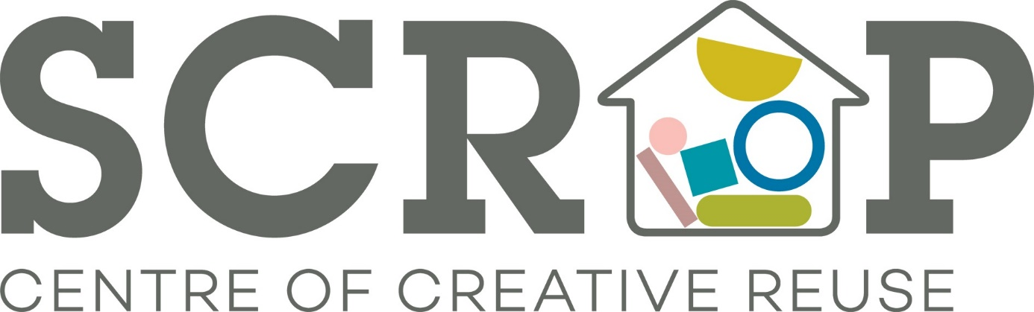

Thank you for your interest in volunteering with Scrap. Please read on for a breakdown of the role currently on offer.
If you are interested in pursuing this please let us know and we will invite you in for a chat with our Volunteer Co-ordinator, Mari, on a Weds, Thurs or Fri between 10am – 4pm. Email us on hello@scrapstuff.co.uk with a little bit about yourself including your availability.
SCRAP Volunteer Role: Store/Stock Assistant
Potential time commitment: Flexible (minimum 4 hour shift)
Available days/time: Weds – Sat 10am – 4pm
Location: Sunnybank Mills, The Spinnning Mill, Farsley Leeds LS28 5UJ
Responsibilities/activity (to include all or some of the following):
- General sorting stock, stocking up and preparation of materials to display in store
- Making up packs of stock
- Making up ‘craft kits’
- Supporting the development of the Scrap online shop
- Helping to unload van and sort materials in our warehouse (optional)
- Some manual work such as lifting boxes and using tools to prepare materials may be required (optional)
Requirements:
- Excellent interpersonal skills including a polite, friendly, and approachable manner (you must be child-friendly)
- Ability to work well with other volunteers as part of a team
- Interest in creative skills and environmental issues (recycling)
Training and support:
Full training on all store assistant responsibilities will be provided, including a general Health and Safety induction and till training (optional). SCRAP will aim to provide opportunities for personal development within your role.
What you will get from this role:
- Develop your skills and experience
- Join a motivated, fun, and creative team of volunteers

- Take pride in the knowledge that you are helping a valuable local social enterprise that benefits your community
- Gain experience that will enhance your CV
- Meet new people throughout Leeds
- Reasonable expenses covered (bus fares and lunch money to the value of £5.00)
Health and safety responsibilities:
To be responsible for your own health and safety and that of others with whom you volunteer by reporting all potential and actual health and safety matters including accidents using the correct procedures.

(end)

