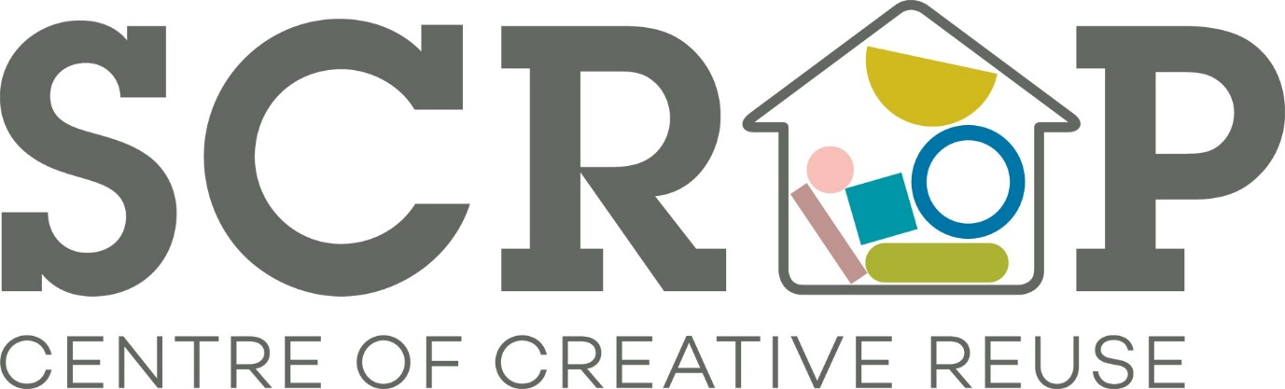
Thank you for your interest in volunteering with Scrap. Please read on for a breakdown of the Scrap Community Craft Café Volunteer role.
If you are interested in pursuing this please let us know and we will invite you in for a chat with our Volunteer Co-ordinator, Mari, on a Weds, Thurs or Fri between 10am – 4pm. Email us on hello@scrapstuff.co.uk with a little bit about yourself including your availability.
SCRAP Volunteer Role: Scrap Community Craft Café
Potential time commitment: Flexible (minimum one day shifts each week*)
Available days/time: Weds – Fri 10am – 4pm
Location: Sunnybank Mills, The Spinning Mill, Farsley Leeds LS28 5UJ
The Scrap Community Craft Café has been created both to provide a creative hub (encouraging people to use the space to work on projects both as individuals and as groups) and as a place for young people with learning disabilities to gain work experience, develop work based skills, confidence and self-esteem. Volunteers must be demonstrably kind, patient and able to guide and appreciate the skill sets we are working to develop with our young people on their work placements.
If you are creative and have a love of making and crafting all the better!
Responsibilities/activity (to include all or some of the following):
Cleaning and preparing kitchen for service
Filling and emptying the dishwasher
Engaging with customers
Taking payments
Clearing and cleaning tables
Cleaning down at the end of the day
Supporting our young people on their work placements
Requirements:
- Excellent interpersonal skills including a polite, friendly, and approachable manner (you must be child-friendly)
- Ability to work well with other volunteers as part of a team
- Interest in creative skills and environmental issues (recycling)
Training and support:
Full training on all aspects related to the Community Craft Cafe will be provided, including a general Health and Safety induction, Food Hygiene and till training. SCRAP will also aim to provide opportunities for personal development within your role.
What you will get from this role:
- Develop your skills and experience
- Join a motivated, fun, and creative team of volunteers
- Take pride in the knowledge that you are helping a valuable local social enterprise that benefits your community
- Gain experience that will enhance your CV
- Meet new people throughout Leeds
- Reasonable expenses covered (bus fares and lunch money to the value of £5.00)
Health and safety responsibilities:
You will be responsible for your own health and safety and that of others with whom you volunteer by reporting all potential and actual health and safety matters including accidents using the correct procedures.
(end)

